Dear BVE Students and Families,

BVE October 2024

Newsletter

1001 Mackenzie Ave, Revelstoke

Tel: 250.837.3085 Web: begbieview.sd19.bc.ca

How quickly September flew by! We sure hope your child is feeling settled into the routines and community of their new classroom, and that they are developing new friendships with their classmates ☺

Our school goals for the year ahead are a continuation of the work we’ve been doing in three main areas:

1. Ensuring a safe, welcoming and engaging school environment – classes are reviewing the BVE Code of Conduct, and it will be shared at the next PAC meeting. Most recently we have begun using the Core Competencies (related to personal and social, thinking, and communication) to recognize students at biweekly assemblies.
2. Maintaining the gains we’ve made in literacy, and enhancing our outcomes in mathematics and numeracy with a student-centred and Data-informed approach. This month we are delighted to welcome Kendra Jacobs, a Numeracy coach from Vernon, who will be doing demonstration lessons in a variety of classes and facilitating educator discussions about Numeracy instruction. Later this Fall, we will be doing a Math Fair to invite students and families to enjoy a fun Math event.
3. Working toward Reconciliation, namely equity in student outcomes, enhancing opportunities for staff, student and family learning about the history and ongoing impact of colonialism, and getting to know the stories, languages, and peoples Indigenous to this place. Last week we recognized Orange Shirt Day, taking time to learn about the harm caused to generations of Indigenous children and families by Canada’s Residential Schools, and thinking about actions we can each take to move toward true Reconciliation. If you are in the school, we invite you to drop by and view the bulletin board created by Marlene Krug, highlighting the ReconciliACTIONS we are doing at BVE.

October also is a time for students to set some learning intentions and goals with the teachers and parents who support them. Goal Setting conferences will be held on October 23 and 24. On these two dates, school will be dismissed at 12:30 pm to facilitate teachers meeting with students and their families those afternoons and evenings. These individual conferences are a chance for reflection on your child’s learning strengths and needs, and a conversation with his or her teacher about learning in the year ahead.

Please read on for much more news, and upcoming school events!

Sincerely,

Ariel McDowell Principal, BVE

**Dates to Note:**

* Oct. 2 Wednesday first free School-wide lunch: Veggie chili and corn bread (bring a spoon and container)
* Oct. 3 BVE Hosts District Cross Country Run (Parent volunteers needed ☺)
* A child jumping over small yellow objects on a basketball court

  Description automatically generatedOct. 4 Friday School-wide Assembly – parents welcome! (8:40-9:10)
* Oct. 7 Monday PAC Meeting 6:30 pm
* Oct. 14 Thanksgiving Monday (no school)
* Oct 16 School-wide free lunch: Spaghetti and meatballs
* Oct. 22 Photo retakes
* Oct. 23 Secwepemc Elder Randy visits
* Oct. 23 & 24 Goal Setting Conferences (dismissal at 12:30pm)
* Oct. 25 Professional Development Day (no school for students)
* Oct. 27th School-wide Assembly – parents welcome! (8:40-9:10)
* Oct. 31st Halloween!

**School Fruit and Vegetable Program**

BVE is again offering the BC School Fruit and Vegetable program, supported by the BC Agriculture in the Classroom Foundation. By participating in this free program, students have the opportunity to try and learn about a variety of fruits and vegetables grown in BC.

**Terry Fox Run**

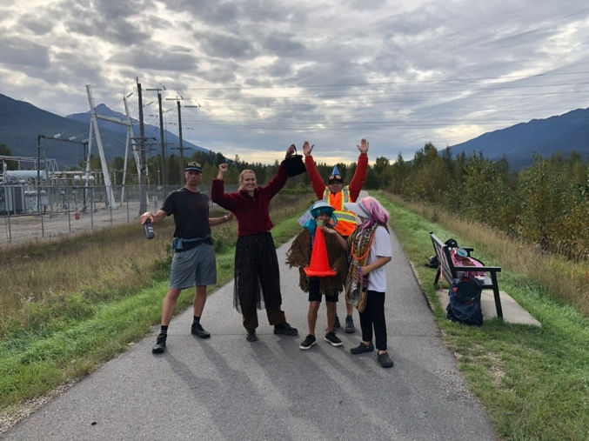We had beautiful weather for this year’s annual Terry Fox School Run. Students ran either the longer 2.3 Km route, or the shorter 1.1 Km route on September 19th . Though we had told Primary students they could turn around at the Worker’s Memorial, most of them carried on down the Green Belt with determination – Terry would be proud! With our request for a “Twoonie for Terry”, and with the BVE fundraising page on the Terry Fox Foundation website, **BVE students raised more than $1100 for cancer research!** A final total will be shared in assembly this week. Way to Go, BVE!

**Photo Retake Day Oct. 22**

If your child missed our photo date this year, or if you are not happy with the photos taken, please let their teacher know you wish to have retakes done. Mountain West Studios is hoping for feedback, so please let us know whether you are happy with the quality of the photos, ease of ordering, etc.

**Goal Setting Conferences**

On October 23rd and 24th , school will be in session 8:25 – 12: 30 to accommodate teachers meeting with students and parents or guardians to discuss goals for the year ahead. Your meeting may be scheduled for a different evening, to make time for all the meetings to happen. If you are unable to attend the time given to you, you can give your child’s classroom teacher a call at the school (250) 837-3085 or send an email to arrange a different time to connect. The purpose of this Conference is to have a shared conversation about your child’s learning, and to include each student in the process of setting learning goals and reflecting on progress. Please see the attached brochure from the District on Communicating Student Learning.

**Extracurricular Sports**

The CROSS-COUNTRY RUNNING season is well underway! We’ve had a great turnout, with well over 30 students participating! The next run is our very own BVE Run coming up this week on Thursday, Oct. 3rd. It takes a lot of volunteers to cheer and direct traffic along the course, so if you can volunteer that afternoon between 3:00 and 3:45 we would be very grateful. The next race will be the annual “Turkey Trot” at CPE on October 10th, and the season wraps up on October 17th with a run in the National Park, hosted by Ecole des Glaciers. A huge thank you to coaches Mr. Weddell, Ms. Hill and Ms. Tomm, and to the many staff and parent volunteers who come out to help host our BVE run!

BADMINTON begins later this month, with opportunities for students in Grades 6 &7 to participate in District Tournaments in November. If you are interested in helping out, please contact the school.

**Indigenous Education Focus for October**

Many classes across the District will have an opportunity to learn about Salmon this month. The October fieldtrip will include a nature walk along the Six Mile area.

**Drop Off and Pick Up**

A reminder that to keep the drop off and pick up zones safe, only families with children in Cornerstones childcare, Kindergarten or Grade One may enter the BVE cul-de-sac by car. Bike traffic is okay to use the cul-de-sac, but limit congestion on our sidewalks, paths and parking area. Please walk your bike or scooter at pick up and drop off.

**PAC NEWS**

The Begbie View Elementary Parent Advisory Council (BVE PAC) supports BVE events, activities, equipment and more throughout the year….and you might not be aware that every BVE parent is a member of the PAC. There are many opportunities throughout the year to contribute – you can help as much or as little as you are able.

This year’s PAC executive is:

1. President: Jo Gawler
2. Vice-President: Alisa Henry
3. Secretary: To Be Determined – if you’re interested, please come to the PAC meeting on Oct. 7
4. Treasurer: Dan Byznya
5. DPAC: Austin Luciow  and  Stacey Lamont
6. Executive at Large: Amanda Argue, Chelsea Meulendyk

Thank you to all the parents who volunteer time to get involved with BVE PAC and support our school!

The next meeting will be held on Tuesday, October 7th  at 6:30 pm at BVE in the Library. Child minding is available.

There are two ongoing fundraisers that the BVE PAC has available. One is Lovable Labels, which sells washer- and dryer-proof personalized labels to help make sure your children’s items make it home. The other fundraiser is Tru Earth eco-friendly household products. Please use this link to access Tru Earth: [tru-earth.sjv.io/BegbieViewElementary](http://tru-earth.sjv.io/BegbieViewElementary)

**STAY CONNECTED!**

Just a reminder to visit our updated website[**begbieview.sd19.bc.ca**](https://begbieview.sd19.bc.ca/)